Lab 7

Regular Expression and Text File

# Introduction

This lab assignment you will write a JavaFx program that extracts some fields from text file() by using a pattern. The pattern is defined by using regular expression in Java. You will retrieve student id from column username, last name and first name from column name.

# Classes

All classes should be part of a package **regexfile**.

**ExtractData**

This class will be used for initialize ArrayList of Last name, First name, Student id and Alphabet of Last name include with:

ArrayList<String> lastname;  
 ArrayList<String> firstname;  
 ArrayList<String> id;  
 ArrayList<Character> al;

**RegexFileJavaFX**

The entry point of an application. The program should have a combo box for Alphabet Last name respect to the last name of student in student list file. The detail of students includes with id, first name and last name will be displayed in a listview beneath the combo box as shown in the below figure.

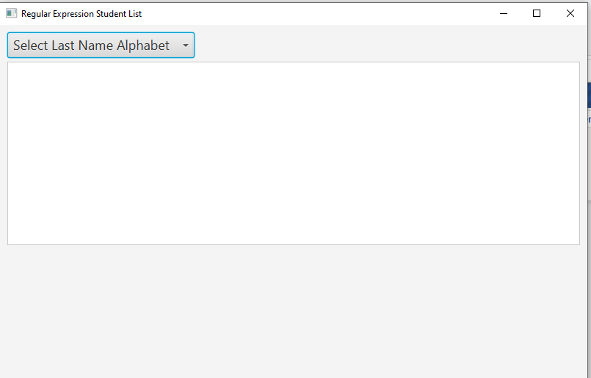

## When user selects the alphabet last name in combo box. The program must display all students who have the last name begin with that alphabet as shown in the below figure.

## 

## Furthermore, the application must display the charts or graphs at least two charts by using Java Chart and Thread that professor introduced in the lab. These charts are in package javafx.scene.chart, the chart must change every 1 or 2 seconds. The chart will be showed under listview as in the below figures:

## 

## 

# Submission

After completing this lab, zip up all the classes in the **regexfile** package and name of the zip file COP3809-LAB7-SYY-XXXX.zip ( YY = 01, 02, or 03 XXXX = Student ID) submit on Canvas.